* To open a new layout, 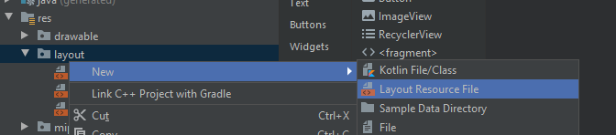
* Layout names must be in lower cases and stuff. Important tip is to add a scrollview to avoid losing views during the changing of orientation of device , when there is 5-10 views
* View option menu : should enable show all constraints. Next button is auto add constraints to parent. Next one is margin. After that clear all constraints.

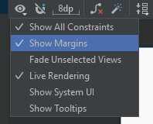

* Last one is the infer constraints icon, its similar to the autoconnection to parent button. It will auto connect the constraints after moving an element.
* Verticalvias is used to control how farm from the parent the element is, for example. .2 will mean the view is 20% below from the top of the screen.
* Chainstyle is another property I should check from android doc
* Layout_width/height have a new property named match constraints here, means it will take all the space available by the constraints.
* Vertical and horizontal guidline is a great way to match up our views
* **Infer Constrains** will automatically add constraints based on the position of the view.

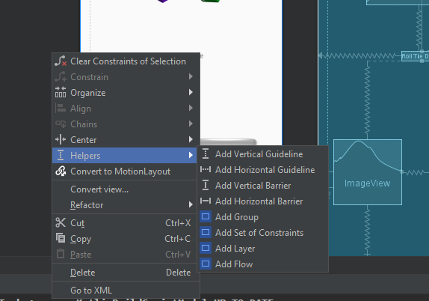

* The guidelines and barriers must study too